Lab Exercise 3 - Multi-Column Indexes and Their Advantages in PostgreSQL

1. Lab Overview
In this lab, you will learn how multi-column indexes can improve query performance when queries frequently use more than one column for filtering or sorting.
We will:
- Create a sample table
- Insert test data
- Run queries without indexes
- Create a multi-column index
- Compare query execution plans
- Understand column order in multi-column indexes
Estimated Time
30–45 minutes

2. Learning Objectives
After completing this lab, you will be able to:
- Understand multi-column indexes.
- Create a multi-column index.
- Use EXPLAIN to examine query execution.
- Understand the importance of column order.
- Identify queries that can benefit from multi-column indexes.

3. Create the Sample Table
Create a table for customer orders:
CREATE TABLE orders (
order_id SERIAL PRIMARY KEY,
customer_name VARCHAR(100),
city VARCHAR(50),
status VARCHAR(20),
order_date DATE,
amount NUMERIC(10,2)
);

4. Insert Sample Data
Insert some sample records:
INSERT INTO orders
(customer_name, city, status, order_date, amount)
VALUES
('Amit', 'Delhi', 'Completed', '2026-01-10', 5000),
('Priya', 'Mumbai', 'Pending', '2026-01-15', 7000),
('Rahul', 'Delhi', 'Completed', '2026-02-05', 3500),
('Sneha', 'Bangalore', 'Cancelled', '2026-02-10', 2500),
('Vikas', 'Delhi', 'Pending', '2026-02-15', 8000),
('Neha', 'Mumbai', 'Completed', '2026-03-01', 4500),
('Rohit', 'Delhi', 'Completed', '2026-03-05', 9000),
('Pooja', 'Bangalore', 'Pending', '2026-03-10', 6500),
('Ankit', 'Mumbai', 'Completed', '2026-03-15', 5500),
('Kavita', 'Delhi', 'Pending', '2026-03-20', 7200);

Check the data:
SELECT *
FROM orders;
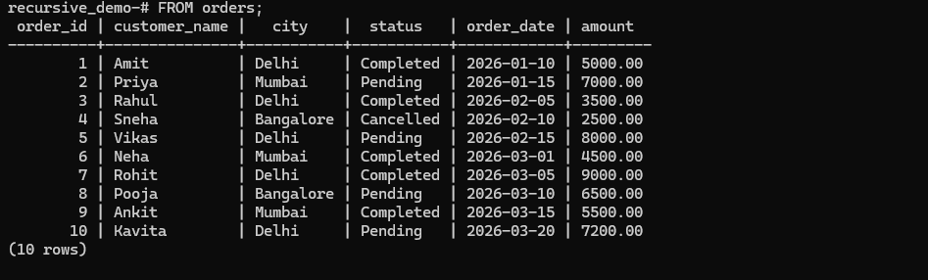

5. Exercise 1 – Query Without a Multi-Column Index
Suppose we frequently search for orders using:
City + Status
Run:
EXPLAIN
SELECT *
FROM orders
WHERE city = 'Delhi'
AND status = 'Completed';
Because the table is very small, PostgreSQL may choose a sequential scan.
You may see something similar to:
Seq Scan on orders
This is normal for a small table.

6. Exercise 2 – Create a Multi-Column Index
Create an index on city and status:
CREATE INDEX idx_orders_city_status
ON orders(city, status);
Check the index:
\d orders

You should see:
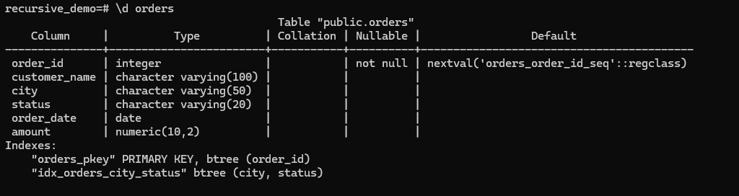
idx_orders_city_status

7. Exercise 3 – Use the Multi-Column Index
Run:
EXPLAIN
SELECT *
FROM orders
WHERE city = 'Delhi'
AND status = 'Completed';
PostgreSQL may now choose an index-based execution plan.
For a small table, PostgreSQL may still choose a sequential scan. This does not mean the index is incorrect.
PostgreSQL considers the estimated cost of each execution plan.

8. Exercise 4 – Test with ANALYZE
Run:
ANALYZE orders;
Then:
EXPLAIN ANALYZE
SELECT *
FROM orders
WHERE city = 'Delhi'
AND status = 'Completed';
EXPLAIN ANALYZE actually executes the query and provides execution information.
Look for information such as:
Planning Time
Execution Time
Rows Removed
Scan type
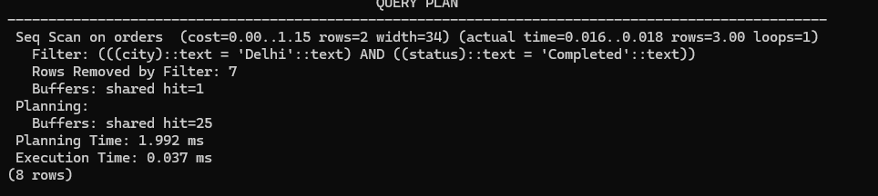

9. Exercise 5 – Understand Column Order
Our index is:
CREATE INDEX idx_orders_city_status
ON orders(city, status);
The order is:
city → status
This is important.
The index is particularly useful for queries such as:
WHERE city = 'Delhi'
AND status = 'Completed'
It can also be useful for:
WHERE city = 'Delhi'
But it is generally less useful for a query that only filters on:
WHERE status = 'Completed'
because status is the second column in the index.

10. Exercise 6 – Query Using First Column
Run:
EXPLAIN ANALYZE
SELECT *
FROM orders
WHERE city = 'Delhi';
The multi-column index:
(city, status)
can potentially support this query because city is the first indexed column.

11. Exercise 7 – Query Using Second Column
Now run:
EXPLAIN ANALYZE
SELECT *
FROM orders
WHERE status = 'Completed';
The index:
(city, status)
is generally not the ideal index for a query that only searches on status.
If this query is very common, you may instead need:
CREATE INDEX idx_orders_status
ON orders(status);
This demonstrates why index column order matters.

12. Exercise 8 – Multi-Column Index with Sorting
Suppose the application frequently runs:
SELECT *
FROM orders
WHERE city = 'Delhi'
AND status = 'Completed'
ORDER BY order_date;
We can create:
CREATE INDEX idx_orders_city_status_date
ON orders(city, status, order_date);
Now the index contains:
city
↓
status
↓
order_date
This can be useful for queries that filter by city and status and then work with the order date.
13. Exercise 9 – View Existing Indexes
Run:
SELECT
indexname,
indexdef
FROM pg_indexes
WHERE tablename = 'orders';
You should see indexes such as:
orders_pkey
idx_orders_city_status
idx_orders_status
idx_orders_city_status_date
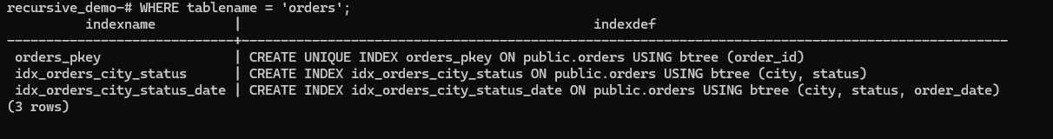

14. Exercise 10 – Compare Single vs Multi-Column Index
Create a single-column index:
CREATE INDEX idx_orders_city
ON orders(city);
Now compare:
EXPLAIN
SELECT *
FROM orders
WHERE city = 'Delhi'
AND status = 'Completed';
with:
EXPLAIN
SELECT *
FROM orders
WHERE city = 'Delhi';

15. Why Use Multi-Column Indexes?
Consider this query:
SELECT *
FROM orders
WHERE city = 'Delhi'
AND status = 'Completed';
A multi-column index:
(city, status)
is designed specifically around this combination.
It can be beneficial when the application frequently searches using the same combination of columns.
For example:
Application Query
↓
city + status
↓
Multi-column Index
↓
Matching rows

16. Important Rule – Column Order
Suppose we have:
CREATE INDEX idx_orders_city_status
ON orders(city, status);
Think of it as:
(city, status)
not:
(status, city)
These are different indexes.
For example:
CREATE INDEX idx_orders_status_city
ON orders(status, city);
has the opposite column order.
The correct order should be based on the application's common query patterns.

